LAB IMPLEMENTATION EXPERIMENT 6
Generative Adversarial Network (GAN) for Synthetic Image Generation
Generative AI Laboratory (CO1, CO2)
Aim
To implement a Generative Adversarial Network using TensorFlow/Keras, train Generator and Discriminator networks adversarially on MNIST and generate synthetic handwritten-digit images from random noise.
Theory
A Generative Adversarial Network (GAN) consists of two neural networks: a Generator and a Discriminator. The Generator maps a random latent noise vector to a synthetic image, while the Discriminator predicts whether an input image is real (from the training data) or generated (synthetic).
The two networks are trained in competition. The Discriminator learns to distinguish real and fake samples, while the Generator learns to produce samples that the Discriminator classifies as real. The process is described as a minimax optimization problem and requires a careful balance between the two networks.
The Generator commonly uses dense or transposed-convolution layers to map latent vectors to images. The Discriminator uses dense or convolution layers and a sigmoid output for real/fake probability. Common training difficulties include mode collapse, unstable convergence and vanishing gradients. Loss curves are useful diagnostics but do not by themselves establish image quality.
Dataset note: the official handout specifies MNIST handwritten digits and normalization to the range [-1, 1]. The BattingCoach image dataset contains cricket bats and is not used for this prescribed digit-generation experiment.
Steps
1. Install TensorFlow/Keras, NumPy and Matplotlib.
2. Load the MNIST training images and normalize pixel values to [-1, 1]. Reshape each image to 28×28×1.
3. Define a latent noise dimension and construct the Generator so it maps noise vectors to 28×28 grayscale images.
4. Construct the Discriminator so it receives an image and returns a real/fake probability.
5. Compile the Discriminator using binary cross-entropy and the Adam optimizer.
6. Build the combined GAN by freezing the Discriminator during the Generator update while keeping it trainable for its own update.
7. Train in mini-batches: update the Discriminator with real and generated images, then update the Generator to fool the Discriminator.
8. Record Generator and Discriminator losses during training and plot their trends.
9. Generate samples from fresh latent vectors at selected training epochs and compare them with real MNIST images.
10. Discuss image sharpness, diversity, stability and any sign of mode collapse.
Code
Core implementation excerpt (the complete runnable workflow is provided in the corresponding notebook).
%pip -q install tensorflow matplotlib
import tensorflow as tf, numpy as np, matplotlib.pyplot as plt
from tensorflow.keras import layers
(x_train, _), (_, _) = tf.keras.datasets.mnist.load_data()
x_train = (x_train.astype("float32") - 127.5) / 127.5
x_train = x_train.reshape((-1, 28, 28, 1))
LATENT_DIM = 100
# Generator: noise vector -> 28 x 28 x 1 image
generator = tf.keras.Sequential([
layers.Input(shape=(LATENT_DIM,)),
layers.Dense(7*7*128, activation="relu"),
layers.Reshape((7, 7, 128)),
layers.Conv2DTranspose(128, 4, strides=2, padding="same", activation="relu"),
layers.Conv2DTranspose(1, 4, strides=2, padding="same", activation="tanh")
])
# Discriminator: image -> real/fake probability
discriminator = tf.keras.Sequential([
layers.Input(shape=(28, 28, 1)), layers.Flatten(),
layers.Dense(256, activation="leaky_relu"),
layers.Dense(1, activation="sigmoid")
])
# Compile the discriminator and combined GAN, then alternate updates.
# The notebook contains the loss functions, training_step and epoch loop.
noise = tf.random.normal((16, LATENT_DIM))
samples = generator(noise, training=False)
print("Generated batch:", samples.shape)
Output
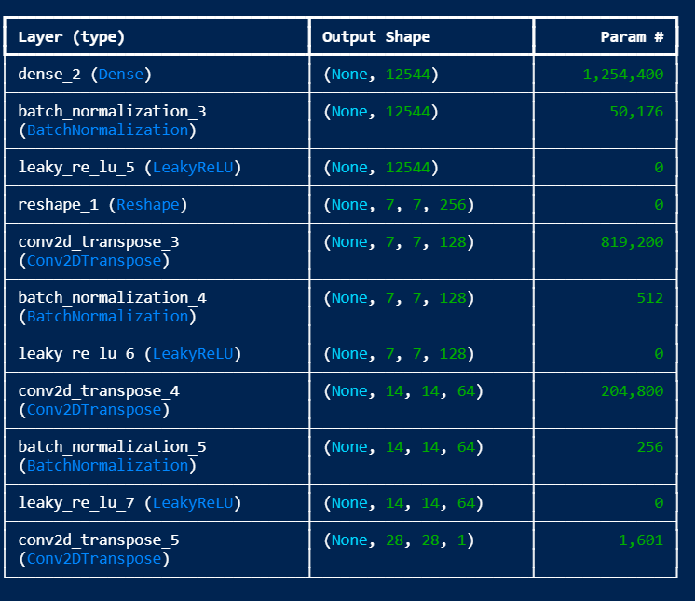
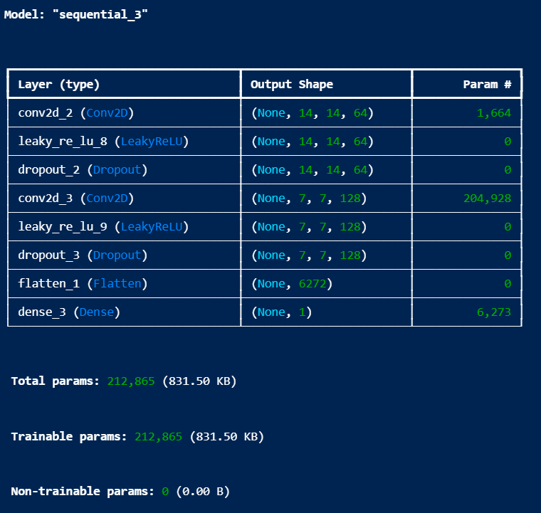

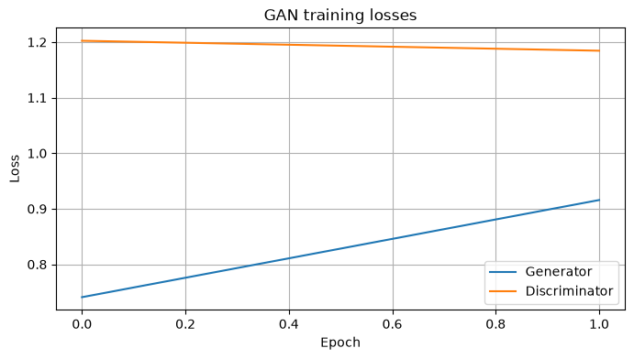

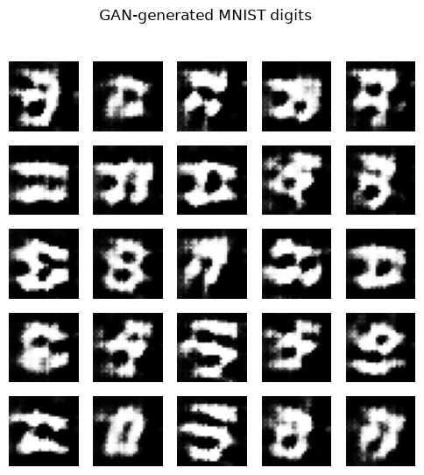

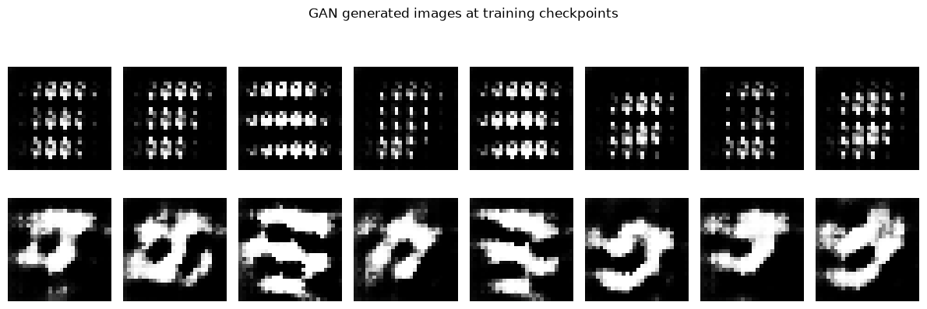

Observation
Record the number of epochs, batch size and final loss values. Describe whether generated digits become more recognizable over time, whether samples are varied and whether the same output patterns repeat. Mention any unstable loss behaviour or possible mode collapse.
Conclusion
The experiment demonstrates adversarial training between a Generator and a Discriminator. The Generator learns to map random noise to image-like samples, while the Discriminator learns to distinguish generated images from real MNIST digits. Complete the conclusion with the observed sample quality, diversity and training stability. The experiment follows the MNIST dataset specified in the lab sheet.

